Partial derivative

Geometrical Meaning
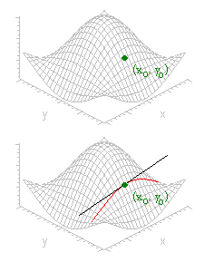
Suppose the graph of is the surface shown. Consider the partial derivative of with respect to at a point ().
Holding constant and varying , we trace out a curve that is the intersection of the surface with the vertical plane
The partial derivative measures the change in per unit increase in along this curve. That is, is just the slope of the curve at . The geometrical interpretation of is similar.

1. Let 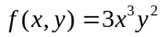. Find
(a) 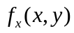 (b) 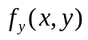 (c) 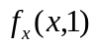 (d) 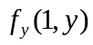
(f) 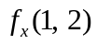 (g) 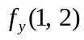.

2. Let 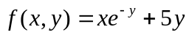
a) Find the Slope of the surface 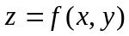 in the x- direction at the point (3,0)
b) Find the slope of the surface in the y direction of the point (3,0).

3. Let 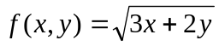
a) Find the Slope of the surface in the x- direction at the point (4,2)
b) Find the slope of the surface in the y direction of the point (4,2)

4. Let 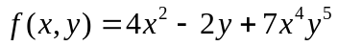 , Find

(a) 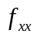 (b) 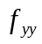 (c) 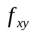 (d) 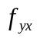.

5. Let 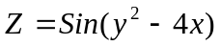
(a) Find the rate of Change of z w. r. to x at the point (2,1) with y kept fixed.
(b) Find the rate of Change of z w. r. to y at the point (2,1) with x kept fixed.

6. Let 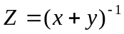
(a) Find the rate of Change of z w. r. to x at the point (-2, 4) with y kept fixed.
(b) Find the rate of Change of z w. r. to y at the point (-2, 4) with x kept fixed

7. Let 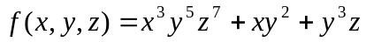 , find
(a) (b) 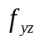 (c) 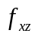 (d) 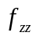 (e) 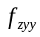 (f) 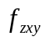 (g) 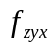 (h) 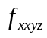.
8. Let 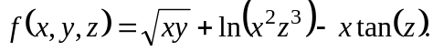 Compute 